Post Course Practical Submission

Student Name:
Date of Birth:
Date of course attendance:
Submission Date:
Instructions

Submit 10 De-identified spirometry results from a subject you have measured
Submissions must be received 1 month after your course date unless an extension is granted. An extension can be granted by contacting the trainer via the email address below.

For each trial attempted supply graphical presentation of each of the trials performed: –
- Volume time graph
- Flow volume curve

Use snipping tool on your computer to provide the information as listed and seen in the examples below: -

- Data for all trials attempted (at least FEV1/ FVC, FEV1, FVC, FIVC, PEF)
- Loops and curves for all trials attempted
- Comments about test acceptability and repeatability.
- Final report showing best three loops and data for best three tests. This report should also include your technical comment and interpretation of results.

Following completion please upload to the online portal as indicated in the screen shot below.

Should you have any questions please email spirometry@kinnecttraining.com.au and
Feedback will be provided for the submission by your trainer/assessor. This feedback will be received via the LMS portal

HOW TO UPLOAD YOUR ASSIGNMENT

The post course submission form can be downloaded in the Post course assignment page – perform 10 spirometry tests
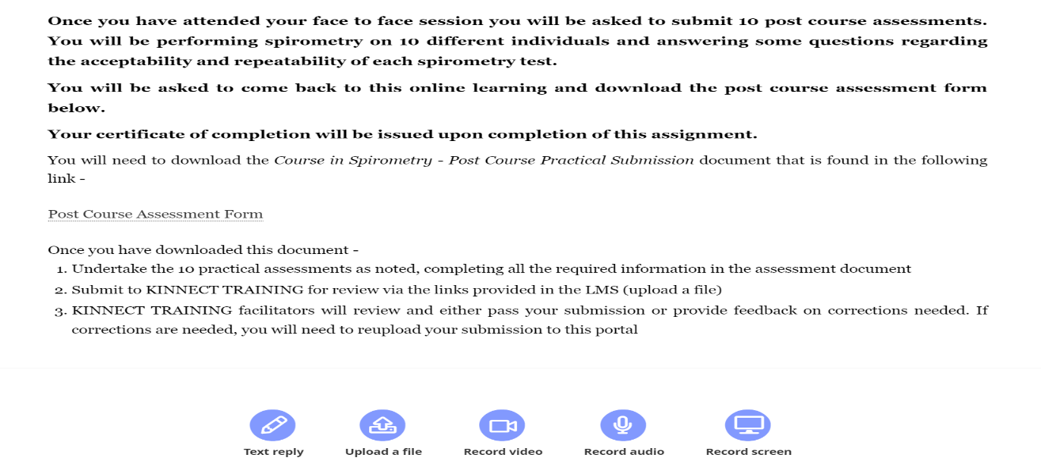
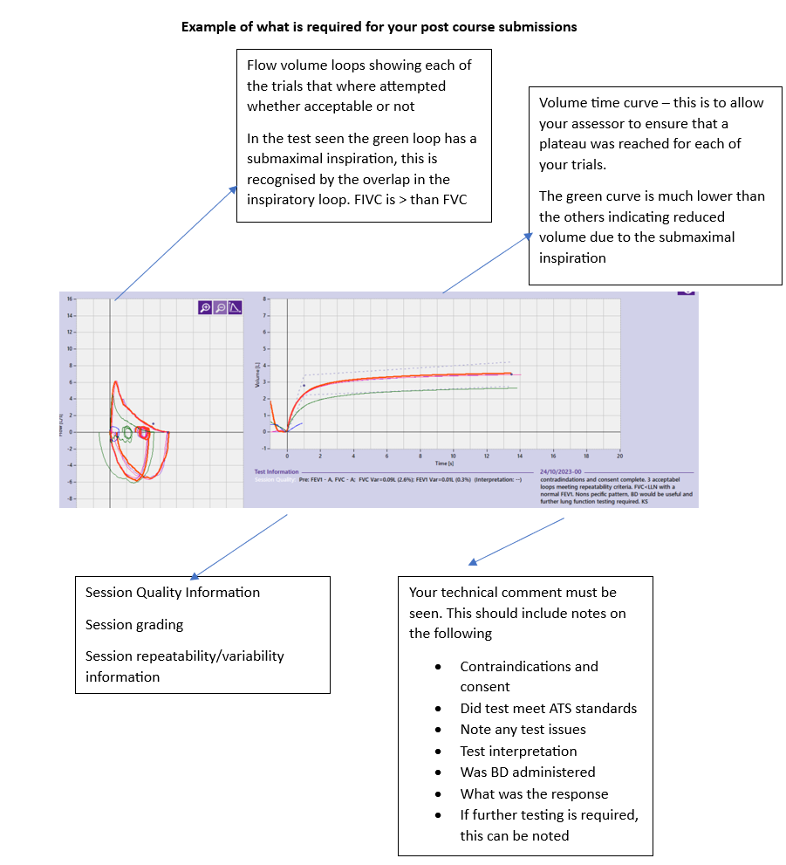
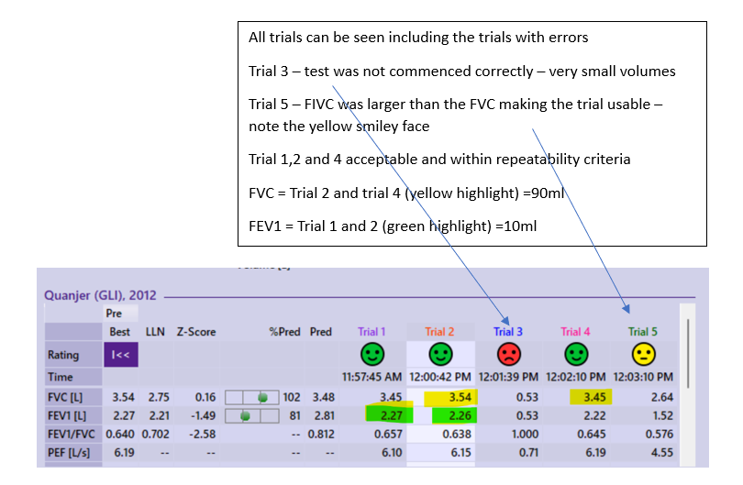
PLEASE ALSO UPLOAD A SCREEN SHOT OF THE FULL REPORT INCLUDING THE BEST THREE LOOPS AND DATA
FOR THE BEST THREE TESTS SUCH AS SHOWN IN THE REPORT BELOW

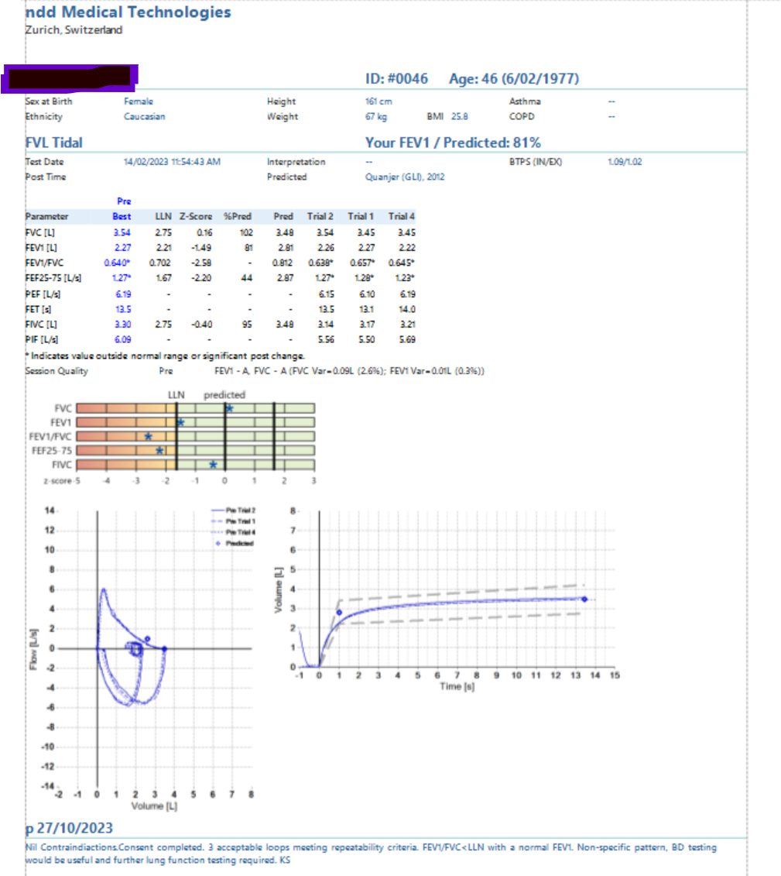

Assessment 1
Parameters and Results (paste screen shot below or attach to document)
Flow Volume Loops Graph (paste screen shot below or attach to document) Please include your test comment in this screenshot | Volume Time Graph (paste screen shot below or attach to document)
Please attach a screen shot of the full report showing the best three loops selected and data for the best three tests.

Question 1
Was a linearity calibration check completed prior to the test?
Yes ☐ | No ☐

Question 2
Were the subject demographics entered correctly?

Have you entered height to the nearest mm?
If you selected an ethnicity other than Caucasian. Please document which category
- Southeast Asian
- Northeast Asian
- Black
- Other
Yes ☐ | No ☐ | Why?

Question 3
Do the following trials (1-8) meet ATS/ERS acceptability criteria?

Select acceptable, unacceptable (note error) or usable

ERRORS:
- Hesitation, slow start
- Premature stop
- Submaximal inspiration (FIVC> 5% than FVC),
- Submaximal expiration (poor PEF)
- Extra breath
- Cough, flow interruption

Where trials were unacceptable, document what error(s) was identified.
If a trial has a FIVC greater than 5% larger than the FVC this makes the trial usable. Consultant should be coaching the applicant to improve their FVC in this instance as we know that they are capable. This ensures we are getting highly accurate information. These trials should ONLY be used if there are NO better trials available.
Trial 1 Acceptable ☐ | Not Acceptable ☐  Error seen: | Usable ☐
Trial 2 Acceptable ☐ | Not acceptable ☐  Error seen: | Usable ☐
Trial 3 Acceptable ☐ | Not acceptable ☐  Error seen: | Usable ☐
Trial 4 Acceptable ☐ | Not acceptable ☐  Error seen: |  | Usable ☐
Trial 5 Acceptable ☐ | Not acceptable ☐  Error seen: |  | Usable ☐
Trial 6 Acceptable ☐ | Not acceptable ☐  Error seen: |  | Usable ☐
Trial 7 Acceptable ☐ | Not acceptable ☐  Error seen: |  | Usable ☐
Trial 8 Acceptable ☐ | Not acceptable ☐  Error seen: |  | Usable ☐
IF POST TRIALS ATTEMPTED | Complete as per pre-BD section
Trial 1 Acceptable ☐ | Not Acceptable ☐  Error seen: |  | Usable ☐
Trial 2 Acceptable ☐ | Not acceptable ☐  Error seen: |  | Usable ☐
Trial 3 Acceptable ☐ | Not acceptable ☐  Error seen: |  | Usable ☐
Trial 4 Acceptable ☐ | Not acceptable ☐  Error seen: |  | Usable ☐
Trial 5 Acceptable ☐ | Not acceptable ☐  Error seen: |  | Usable ☐
Trial 6 Acceptable ☐ | Not acceptable ☐  Error seen: |  | Usable ☐
Trial 7 Acceptable ☐ | Not acceptable ☐  Error seen: |  | Usable ☐
Trial 8 Acceptable ☐ | Not acceptable ☐  Error seen: |  | Usable ☐

Question 4
Did the subject achieve 3 technically acceptable trials?
If you document yes here and there were not 3 acceptable trials, this will result in a failure, and requirement to submit an additional assessment
Yes ☐ | No ☐

Question 5
Does FEV1 meet ATS/ERS repeatability criteria? What was the difference between the two largest?
Yes ☐ | No ☐

Question 6
Does FVC meet ATS/ERS repeatability criteria? What was the difference between the two largest?
Yes ☐ | No ☐

Question 7
Has an appropriate technical comment been entered on the report? If you cannot see the comment in the screenshot above, please type here or add screen shot in this section
Yes ☐ | No ☐

Question 8
If not normal, select which pattern is present. (Obstructive, Restrictive, or Mixed or non-specific).

Obstruction
FEV1/FVC ratio <LLN and
FEV1<LLN
Restriction
FVC<LLN sometimes with FEV1/FVC ratio normal OR
FEV1/FVC >LLN
Mixed
FEV1/FVC <LLN and FEV1 <LLN and FVC <LLN
Non-Specific patterns
FEV1/FVC ratio <LLN only with a normal FEV1
FVC or FEV1<LLN but the FEV1/FVC ratio is normal
(this pattern does not follow other patterns rules)

Obstruction ☐ | Restriction ☐ | Mixed  ☐ | Non-Specific  ☐
Z score Classification
FEV1 z score is used to grade obstruction. Restriction is classified more accurately using lung volumes.
-1.65 – - 2.5 = Mild ☐
-2.5 – - 4.0 = Moderate ☐
> - 4.0 = Severe ☐

Question 9  If post bd spirometry was performed provide details on the bronchodilator response. Was it significant? – tick yes or no  If yes, was there a significant improvement following bronchodilator?  A change of >10% is considered a significant BDR response in line with the 2022 ERS / ATS interpretative standards for lung function testing.  POST BD VALUE -PRE BD VALUE x100/ PREDICTED GLI VALUE |  |  | Overall Mark:  ☐Pass  ☐Fail  ☐Needs Review
Yes ☐ | No ☐ | If yes, a significant improvement was noted in -  FEV1 by ___________%  FVC by ___________%

Assessment 2
Parameters and Results (paste screen shot below or attach to document)
Flow Volume Loops Graph (paste screen shot below or attach to document) Please include your test comment in this screenshot | Volume Time Graph (paste screen shot below or attach to document)
Please attach a screenshot of the full report showing the best three loops selected and data for the best three tests.

Question 1
Was a linearity calibration check completed prior to the test?
Yes ☐ | No ☐

Question 2
Were the subject demographics entered correctly?

Have you entered height to the nearest mm?
If you selected an ethnicity other than Caucasian. Please document which category
- Southeast Asian
- Northeast Asian
- Black
- Other
Yes ☐ | No ☐ | Why?

Question 3
Do the following trials (1-8) meet ATS/ERS acceptability criteria?

Select acceptable, unacceptable (note error) or usable.

ERRORS:
- Hesitation, slow start
- Premature stop
- Submaximal inspiration (FIVC> 5% than FVC)
- Submaximal expiration (poor PEF)
- Extra breath
- Cough, flow interruption

Where trials were unacceptable, document what error(s) was identified.
If a trial has a FIVC greater than 5% larger than the FVC this makes the trial usable. Consultant should be coaching the applicant to improve their FVC in this instance as we know that they are capable. This ensures we are getting highly accurate information. These trials should ONLY be used if there are NO better trials available.
Trial 1 Acceptable ☐ | Not Acceptable ☐  Error seen: | Usable ☐
Trial 2 Acceptable ☐ | Not acceptable ☐  Error seen: | Usable ☐
Trial 3 Acceptable ☐ | Not acceptable ☐  Error seen: | Usable ☐
Trial 4 Acceptable ☐ | Not acceptable ☐  Error seen: |  | Usable ☐
Trial 5 Acceptable ☐ | Not acceptable ☐  Error seen: |  | Usable ☐
Trial 6 Acceptable ☐ | Not acceptable ☐  Error seen: |  | Usable ☐
Trial 7 Acceptable ☐ | Not acceptable ☐  Error seen: |  | Usable ☐
Trial 8 Acceptable ☐ | Not acceptable ☐  Error seen: |  | Usable ☐
IF POST TRIALS ATTEMPTED | Complete as per pre-BD section
Trial 1 Acceptable ☐ | Not Acceptable ☐  Error seen: |  | Usable ☐
Trial 2 Acceptable ☐ | Not acceptable ☐  Error seen: |  | Usable ☐
Trial 3 Acceptable ☐ | Not acceptable ☐  Error seen: |  | Usable ☐
Trial 4 Acceptable ☐ | Not acceptable ☐  Error seen: |  | Usable ☐
Trial 5 Acceptable ☐ | Not acceptable ☐  Error seen: |  | Usable ☐
Trial 6 Acceptable ☐ | Not acceptable ☐  Error seen: |  | Usable ☐
Trial 7 Acceptable ☐ | Not acceptable ☐  Error seen: |  | Usable ☐
Trial 8 Acceptable ☐ | Not acceptable ☐  Error seen: |  | Usable ☐

Question 4
Did the subject achieve 3 technically acceptable trials?
If you document yes here and there were not 3 acceptable trials, this will result in a failure, and requirement to submit an additional assessment
Yes ☐ | No ☐

Question 5
Does FEV1 meet ATS/ERS repeatability criteria? What was the difference between the two largest?
Yes ☐ | No ☐

Question 6
Does FVC meet ATS/ERS repeatability criteria? What was the difference between the two largest?
Yes ☐ | No ☐

Question 7
Has an appropriate technical comment been entered on the report? If you cannot see the comment in the screenshot above, please type here or add screen shot in this section
Yes ☐ | No ☐

Question 8
If not normal, select which pattern is present. (Obstructive, Restrictive, or Mixed or non-specific).

Obstruction
FEV1/FVC ratio <LLN and
FEV1<LLN
Restriction
FVC<LLN sometimes with FEV1/FVC ratio normal OR
FEV1/FVC >LLN
Mixed
FEV1/FVC <LLN and FEV1 <LLN and FVC <LLN
Non-Specific patterns
FEV1/FVC ratio <LLN only with a normal FEV1
FVC or FEV1<LLN but the FEV1/FVC ratio is normal
(this pattern does not follow other patterns rules)

Obstruction ☐ | Restriction ☐ | Mixed  ☐ | Non-Specific  ☐
Z score Classification
FEV1 z score is used to grade obstruction. Restriction is classified more accurately using lung volumes.
-1.65 – - 2.5 = Mild ☐
-2.5 – - 4.0 = Moderate ☐
> - 4.0 = Severe ☐

Question 9  If post bd spirometry was performed provide details on the bronchodilator response. Was it significant? – tick yes or no  If yes, was there a significant improvement following bronchodilator?  A change of >10% is considered a significant BDR response in line with the 2022 ERS / ATS interpretative standards for lung function testing.  POST BD VALUE -PRE BD VALUE x100/ PREDICTED GLI VALUE |  |  | Overall Mark:  ☐Pass  ☐Fail  ☐Needs Review
Yes ☐ | No ☐ | If Yes, a significant improvement was noted in -  FEV1 by ___________%  FVC by ___________%

Assessment 3
Parameters and Results (paste screen shot below or attach to document)
Flow Volume Loops Graph (paste screen shot below or attach to document) Please include your test comment in this screenshot | Volume Time Graph (paste screen shot below or attach to document)
Please attach a screenshot of the full report showing the best three loops selected and data for the best three tests.

Question 1
Was a linearity calibration check completed prior to the test?
Yes ☐ | No ☐

Question 2
Were the subject demographics entered correctly?

Have you entered height to the nearest mm?
If you selected an ethnicity other than Caucasian. Please document which category
- Southeast Asian
- Northeast Asian
- Black
- Other
Yes ☐ | No ☐ | Why?

Question 3
Do the following trials (1-8) meet ATS/ERS acceptability criteria?

Select acceptable, unacceptable (note error) or usable.

ERRORS:
- Hesitation, slow start
- Premature stop
- Submaximal inspiration (FIVC> 5% than FVC)
- Submaximal expiration (poor PEF)
- Extra breath
- Cough, flow interruption

Where trials were unacceptable, document what error(s) was identified.
If a trial has a FIVC greater than 5% larger than the FVC this makes the trial usable. Consultant should be coaching the applicant to improve their FVC in this instance as we know that they are capable. This ensures we are getting highly accurate information. These trials should ONLY be used if there are NO better trials available.
Trial 1 Acceptable ☐ | Not Acceptable ☐  Error seen: | Usable ☐
Trial 2 Acceptable ☐ | Not acceptable ☐  Error seen: | Usable ☐
Trial 3 Acceptable ☐ | Not acceptable ☐  Error seen: | Usable ☐
Trial 4 Acceptable ☐ | Not acceptable ☐  Error seen: |  | Usable ☐
Trial 5 Acceptable ☐ | Not acceptable ☐  Error seen: |  | Usable ☐
Trial 6 Acceptable ☐ | Not acceptable ☐  Error seen: |  | Usable ☐
Trial 7 Acceptable ☐ | Not acceptable ☐  Error seen: |  | Usable ☐
Trial 8 Acceptable ☐ | Not acceptable ☐  Error seen: |  | Usable ☐
IF POST TRIALS ATTEMPTED | Complete as per pre-BD section
Trial 1 Acceptable ☐ | Not Acceptable ☐  Error seen: |  | Usable ☐
Trial 2 Acceptable ☐ | Not acceptable ☐  Error seen: |  | Usable ☐
Trial 3 Acceptable ☐ | Not acceptable ☐  Error seen: |  | Usable ☐
Trial 4 Acceptable ☐ | Not acceptable ☐  Error seen: |  | Usable ☐
Trial 5 Acceptable ☐ | Not acceptable ☐  Error seen: |  | Usable ☐
Trial 6 Acceptable ☐ | Not acceptable ☐  Error seen: |  | Usable ☐
Trial 7 Acceptable ☐ | Not acceptable ☐  Error seen: |  | Usable ☐
Trial 8 Acceptable ☐ | Not acceptable ☐  Error seen: |  | Usable ☐

Question 4
Did the subject achieve 3 technically acceptable trials?
If you document yes here and there were not 3 acceptable trials, this will result in a failure, and requirement to submit an additional assessment
Yes ☐ | No ☐

Question 5
Does FEV1 meet ATS/ERS repeatability criteria? What was the difference between the two largest?
Yes ☐ | No ☐

Question 6
Does FVC meet ATS/ERS repeatability criteria? What was the difference between the two largest?
Yes ☐ | No ☐

Question 7
Has an appropriate technical comment been entered on the report? If you cannot see the comment in the screenshot above, please type here or add screen shot in this section
Yes ☐ | No ☐

Question 8
If not normal, select which pattern is present. (Obstructive, Restrictive, or Mixed or non-specific).

Obstruction
FEV1/FVC ratio <LLN and
FEV1<LLN
Restriction
FVC<LLN sometimes with FEV1/FVC ratio normal OR
FEV1/FVC >LLN
Mixed
FEV1/FVC <LLN and FEV1 <LLN and FVC <LLN
Non-Specific patterns
FEV1/FVC ratio <LLN only with a normal FEV1
FVC or FEV1<LLN but the FEV1/FVC ratio is normal
(this pattern does not follow other patterns rules)

Obstruction ☐ | Restriction ☐ | Mixed  ☐ | Non-Specific  ☐
Z score Classification
FEV1 z score is used to grade obstruction. Restriction is classified more accurately using lung volumes.
-1.65 – - 2.5 = Mild ☐
-2.5 – - 4.0 = Moderate ☐
> - 4.0 = Severe ☐

Question 9  If post bd spirometry was performed provide details on the bronchodilator response. Was it significant – tick yes or no  If yes, was there a significant improvement following bronchodilator?  A change of >10% is considered a significant BDR response in line with the 2022 ERS / ATS interpretative standards for lung function testing.  POST BD VALUE -PRE BD VALUE x100/ PREDICTED GLI VALUE |  |  | Overall Mark:  ☐Pass  ☐Fail  ☐Needs Review
Yes ☐ | No ☐ | If yes, a significant improvement was noted in -  FEV1 by ___________%  FVC by ___________%

Assessment 4
Parameters and Results (paste screen shot below or attach to document)
Flow Volume Loops Graph (paste screen shot below or attach to document) Please include your test comment in this screenshot | Volume Time Graph (paste screen shot below or attach to document)
Please attach a screenshot of the full report showing the best three loops selected and data for the best three tests.

Question 1
Was a linearity calibration check completed prior to the test?
Yes ☐ | No ☐

Question 2
Were the subject demographics entered correctly?

Have you entered height to the nearest mm?
If you selected an ethnicity other than Caucasian. Please document which category
- Southeast Asian
- Northeast Asian
- Black
- Other
Yes ☐ | No ☐ | Why?

Question 3
Do the following trials (1-8) meet ATS/ERS acceptability criteria?

Select acceptable, unacceptable (note error) or usable.

ERRORS:
- Hesitation, slow start
- Premature stop
- Submaximal inspiration (FIVC> 5% than FVC)
- Submaximal expiration (poor PEF)
- Extra breath
- Cough, flow interruption

Where trials were unacceptable, document what error(s) was identified.
If a trial has a FIVC greater than 5% larger than the FVC this makes the trial usable. Consultant should be coaching the applicant to improve their FVC in this instance as we know that they are capable. This ensures we are getting highly accurate information. These trials should ONLY be used if there are NO better trials available.
Trial 1 Acceptable ☐ | Not Acceptable ☐  Error seen: | Usable ☐
Trial 2 Acceptable ☐ | Not acceptable ☐  Error seen: | Usable ☐
Trial 3 Acceptable ☐ | Not acceptable ☐  Error seen: | Usable ☐
Trial 4 Acceptable ☐ | Not acceptable ☐  Error seen: |  | Usable ☐
Trial 5 Acceptable ☐ | Not acceptable ☐  Error seen: |  | Usable ☐
Trial 6 Acceptable ☐ | Not acceptable ☐  Error seen: |  | Usable ☐
Trial 7 Acceptable ☐ | Not acceptable ☐  Error seen: |  | Usable ☐
Trial 8 Acceptable ☐ | Not acceptable ☐  Error seen: |  | Usable ☐
IF POST TRIALS ATTEMPTED | Complete as per pre-BD section
Trial 1 Acceptable ☐ | Not Acceptable ☐  Error seen: |  | Usable ☐
Trial 2 Acceptable ☐ | Not acceptable ☐  Error seen: |  | Usable ☐
Trial 3 Acceptable ☐ | Not acceptable ☐  Error seen: |  | Usable ☐
Trial 4 Acceptable ☐ | Not acceptable ☐  Error seen: |  | Usable ☐
Trial 5 Acceptable ☐ | Not acceptable ☐  Error seen: |  | Usable ☐
Trial 6 Acceptable ☐ | Not acceptable ☐  Error seen: |  | Usable ☐
Trial 7 Acceptable ☐ | Not acceptable ☐  Error seen: |  | Usable ☐
Trial 8 Acceptable ☐ | Not acceptable ☐  Error seen: |  | Usable ☐

Question 4
Did the subject achieve 3 technically acceptable trials?
If you document yes here and there were not 3 acceptable trials, this will result in a failure, and requirement to submit an additional assessment
Yes ☐ | No ☐

Question 5
Does FEV1 meet ATS/ERS repeatability criteria? What was the difference between the two largest?
Yes ☐ | No ☐

Question 6
Does FVC meet ATS/ERS repeatability criteria? What was the difference between the two largest?
Yes ☐ | No ☐

Question 7
Has an appropriate technical comment been entered on the report? If you cannot see the comment in the screenshot above, please type here or add screen shot in this section
Yes ☐ | No ☐

Question 8
If not normal, select which pattern is present. (Obstructive, Restrictive, or Mixed or non-specific).

Obstruction
FEV1/FVC ratio <LLN and
FEV1<LLN
Restriction
FVC<LLN sometimes with FEV1/FVC ratio normal OR
FEV1/FVC >LLN
Mixed
FEV1/FVC <LLN and FEV1 <LLN and FVC <LLN
Non-Specific patterns
FEV1/FVC ratio <LLN only with a normal FEV1
FVC or FEV1<LLN but the FEV1/FVC ratio is normal
(this pattern does not follow other patterns rules)

Obstruction ☐ | Restriction ☐ | Mixed  ☐ | Non-Specific  ☐
Z score Classification
FEV1 z score is used to grade obstruction. Restriction is classified more accurately using lung volumes.
-1.65 – - 2.5 = Mild ☐
-2.5 – - 4.0 = Moderate ☐
> - 4.0 = Severe ☐

Question 9  If post bd spirometry was performed provide details on the bronchodilator response. Was it significant – tick yes or no  If yes, was there a significant improvement following bronchodilator?  A change of >10% is considered a significant BDR response in line with the 2022 ERS / ATS interpretative standards for lung function testing.  POST BD VALUE -PRE BD VALUE x100/ PREDICTED GLI VALUE | Overall Mark:  ☐Pass  ☐Fail  ☐Needs Review

Assessment 5
Parameters and Results (paste screen shot below or attach to document)
Flow Volume Loops Graph (paste screen shot below or attach to document) Please include your test comment in this screenshot | Volume Time Graph (paste screen shot below or attach to document)
Please attach a screenshot of the full report showing the best three loops selected and data for the best three tests.

Question 1
Was a linearity calibration check completed prior to the test?
Yes ☐ | No ☐

Question 2
Were the subject demographics entered correctly?

Have you entered height to the nearest mm?
If you selected an ethnicity other than Caucasian. Please document which category
- Southeast Asian
- Northeast Asian
- Black
- Other
Yes ☐ | No ☐ | Why?

Question 3
Do the following trials (1-8) meet ATS/ERS acceptability criteria?

Select acceptable, unacceptable (note error) or usable.

ERRORS:
- Hesitation, slow start
- Premature stop
- Submaximal inspiration (FIVC> 5% than FVC)
- Submaximal expiration (poor PEF)
- Extra breath
- Cough, flow interruption

Where trials were unacceptable, document what error(s) was identified.
If a trial has a FIVC greater than 5% larger than the FVC this makes the trial usable. Consultant should be coaching the applicant to improve their FVC in this instance as we know that they are capable. This ensures we are getting highly accurate information. These trials should ONLY be used if there are NO better trials available.
Trial 1 Acceptable ☐ | Not Acceptable ☐  Error seen: | Usable ☐
Trial 2 Acceptable ☐ | Not acceptable ☐  Error seen: | Usable ☐
Trial 3 Acceptable ☐ | Not acceptable ☐  Error seen: | Usable ☐
Trial 4 Acceptable ☐ | Not acceptable ☐  Error seen: |  | Usable ☐
Trial 5 Acceptable ☐ | Not acceptable ☐  Error seen: |  | Usable ☐
Trial 6 Acceptable ☐ | Not acceptable ☐  Error seen: |  | Usable ☐
Trial 7 Acceptable ☐ | Not acceptable ☐  Error seen: |  | Usable ☐
Trial 8 Acceptable ☐ | Not acceptable ☐  Error seen: |  | Usable ☐
IF POST TRIALS ATTEMPTED | Complete as per pre-BD section
Trial 1 Acceptable ☐ | Not Acceptable ☐  Error seen: |  | Usable ☐
Trial 2 Acceptable ☐ | Not acceptable ☐  Error seen: |  | Usable ☐
Trial 3 Acceptable ☐ | Not acceptable ☐  Error seen: |  | Usable ☐
Trial 4 Acceptable ☐ | Not acceptable ☐  Error seen: |  | Usable ☐
Trial 5 Acceptable ☐ | Not acceptable ☐  Error seen: |  | Usable ☐
Trial 6 Acceptable ☐ | Not acceptable ☐  Error seen: |  | Usable ☐
Trial 7 Acceptable ☐ | Not acceptable ☐  Error seen: |  | Usable ☐
Trial 8 Acceptable ☐ | Not acceptable ☐  Error seen: |  | Usable ☐

Question 4
Did the subject achieve 3 technically acceptable trials?
If you document yes here and there were not 3 acceptable trials, this will result in a failure, and requirement to submit an additional assessment
Yes ☐ | No ☐

Question 5
Does FEV1 meet ATS/ERS repeatability criteria? What was the difference between the two largest?
Yes ☐ | No ☐

Question 6
Does FVC meet ATS/ERS repeatability criteria? What was the difference between the two largest?
Yes ☐ | No ☐

Question 7
Has an appropriate technical comment been entered on the report? If you cannot see the comment in the screenshot above, please type here or add screen shot in this section
Yes ☐ | No ☐

Question 8
If not normal, select which pattern is present. (Obstructive, Restrictive, or Mixed or non-specific).

Obstruction
FEV1/FVC ratio <LLN and
FEV1<LLN
Restriction
FVC<LLN sometimes with FEV1/FVC ratio normal OR
FEV1/FVC >LLN
Mixed
FEV1/FVC <LLN and FEV1 <LLN and FVC <LLN
Non-Specific patterns
FEV1/FVC ratio <LLN only with a normal FEV1
FVC or FEV1<LLN but the FEV1/FVC ratio is normal
(this pattern does not follow other patterns rules)

Obstruction ☐ | Restriction ☐ | Mixed  ☐ | Non-Specific  ☐
Z score Classification
FEV1 z score is used to grade obstruction. Restriction is classified more accurately using lung volumes.
-1.65 – - 2.5 = Mild ☐
-2.5 – - 4.0 = Moderate ☐
> - 4.0 = Severe ☐

Question 9  If post bd spirometry was performed provide details on the bronchodilator response. Was it significant – tick yes or no  If yes, was there a significant improvement following bronchodilator?  A change of >10% is considered a significant BDR response in line with the 2022 ERS / ATS interpretative standards for lung function testing.  POST BD VALUE -PRE BD VALUE x100/ PREDICTED GLI VALUE | Overall Mark:  ☐Pass  ☐Fail  ☐Needs Review

Assessment 6
Parameters and Results (paste screen shot below or attach to document)
Flow Volume Loops Graph (paste screen shot below or attach to document) Please include your test comment in this screenshot | Volume Time Graph (paste screen shot below or attach to document)
Please attach a screenshot of the full report showing the best three loops selected and data for the best three tests.

Question 1
Was a linearity calibration check completed prior to the test?
Yes ☐ | No ☐

Question 2
Were the subject demographics entered correctly?

Have you entered height to the nearest mm?
If you selected an ethnicity other than Caucasian. Please document which category
- Southeast Asian
- Northeast Asian
- Black
- Other
Yes ☐ | No ☐ | Why?

Question 3
Do the following trials (1-8) meet ATS/ERS acceptability criteria?

Select acceptable, unacceptable (note error) or usable.

ERRORS:
- Hesitation, slow start
- Premature stop
- Submaximal inspiration (FIVC> 5% than FVC)
- Submaximal expiration (poor PEF)
- Extra breath
- Cough, flow interruption

Where trials were unacceptable, document what error(s) was identified.
If a trial has a FIVC greater than 5% larger than the FVC this makes the trial usable. Consultant should be coaching the applicant to improve their FVC in this instance as we know that they are capable. This ensures we are getting highly accurate information. These trials should ONLY be used if there are NO better trials available.
Trial 1 Acceptable ☐ | Not Acceptable ☐  Error seen: | Usable ☐
Trial 2 Acceptable ☐ | Not acceptable ☐  Error seen: | Usable ☐
Trial 3 Acceptable ☐ | Not acceptable ☐  Error seen: | Usable ☐
Trial 4 Acceptable ☐ | Not acceptable ☐  Error seen: |  | Usable ☐
Trial 5 Acceptable ☐ | Not acceptable ☐  Error seen: |  | Usable ☐
Trial 6 Acceptable ☐ | Not acceptable ☐  Error seen: |  | Usable ☐
Trial 7 Acceptable ☐ | Not acceptable ☐  Error seen: |  | Usable ☐
Trial 8 Acceptable ☐ | Not acceptable ☐  Error seen: |  | Usable ☐
IF POST TRIALS ATTEMPTED | Complete as per pre-BD section
Trial 1 Acceptable ☐ | Not Acceptable ☐  Error seen: |  | Usable ☐
Trial 2 Acceptable ☐ | Not acceptable ☐  Error seen: |  | Usable ☐
Trial 3 Acceptable ☐ | Not acceptable ☐  Error seen: |  | Usable ☐
Trial 4 Acceptable ☐ | Not acceptable ☐  Error seen: |  | Usable ☐
Trial 5 Acceptable ☐ | Not acceptable ☐  Error seen: |  | Usable ☐
Trial 6 Acceptable ☐ | Not acceptable ☐  Error seen: |  | Usable ☐
Trial 7 Acceptable ☐ | Not acceptable ☐  Error seen: |  | Usable ☐
Trial 8 Acceptable ☐ | Not acceptable ☐  Error seen: |  | Usable ☐

Question 4
Did the subject achieve 3 technically acceptable trials?
If you document yes here and there were not 3 acceptable trials, this will result in a failure, and requirement to submit an additional assessment
Yes ☐ | No ☐

Question 5
Does FEV1 meet ATS/ERS repeatability criteria? What was the difference between the two largest?
Yes ☐ | No ☐

Question 6
Does FVC meet ATS/ERS repeatability criteria? What was the difference between the two largest?
Yes ☐ | No ☐

Question 7
Has an appropriate technical comment been entered on the report? If you cannot see the comment in the screenshot above, please type here or add screen shot in this section
Yes ☐ | No ☐

Question 8
If not normal, select which pattern is present. (Obstructive, Restrictive, or Mixed or non-specific).

Obstruction
FEV1/FVC ratio <LLN and
FEV1<LLN
Restriction
FVC<LLN sometimes with FEV1/FVC ratio normal OR
FEV1/FVC >LLN
Mixed
FEV1/FVC <LLN and FEV1 <LLN and FVC <LLN
Non-Specific patterns
FEV1/FVC ratio <LLN only with a normal FEV1
FVC or FEV1<LLN but the FEV1/FVC ratio is normal
(this pattern does not follow other patterns rules)

Obstruction ☐ | Restriction ☐ | Mixed  ☐ | Non-Specific  ☐
Z score Classification
FEV1 z score is used to grade obstruction. Restriction is classified more accurately using lung volumes.
-1.65 – - 2.5 = Mild ☐
-2.5 – - 4.0 = Moderate ☐
> - 4.0 = Severe ☐

Question 9  If post bd spirometry was performed provide details on the bronchodilator response. Was it significant – tick yes or no  If yes, was there a significant improvement following bronchodilator?  A change of >10% is considered a significant BDR response in line with the 2022 ERS / ATS interpretative standards for lung function testing.  POST BD VALUE -PRE BD VALUE x100/ PREDICTED GLI VALUE | Overall Mark:  ☐Pass  ☐Fail  ☐Needs Review

Assessment 7
Parameters and Results (paste screen shot below or attach to document)
Flow Volume Loops Graph (paste screen shot below or attach to document) Please include your test comment in this screenshot | Volume Time Graph (paste screen shot below or attach to document)
Please attach a screenshot of the full report showing the best three loops selected and data for the best three tests.

Question 1
Was a linearity calibration check completed prior to the test?
Yes ☐ | No ☐

Question 2
Were the subject demographics entered correctly?

Have you entered height to the nearest mm?
If you selected an ethnicity other than Caucasian. Please document which category
- Southeast Asian
- Northeast Asian
- Black
- Other
Yes ☐ | No ☐ | Why?

Question 3
Do the following trials (1-8) meet ATS/ERS acceptability criteria?

Select acceptable, unacceptable (note error) or usable.

ERRORS:
- Hesitation, slow start
- Premature stop
- Submaximal inspiration (FIVC> 5% than FVC)
- Submaximal expiration (poor PEF)
- Extra breath
- Cough, flow interruption

Where trials were unacceptable, document what error(s) was identified.
If a trial has a FIVC greater than 5% larger than the FVC this makes the trial usable. Consultant should be coaching the applicant to improve their FVC in this instance as we know that they are capable. This ensures we are getting highly accurate information. These trials should ONLY be used if there are NO better trials available.
Trial 1 Acceptable ☐ | Not Acceptable ☐  Error seen: | Usable ☐
Trial 2 Acceptable ☐ | Not acceptable ☐  Error seen: | Usable ☐
Trial 3 Acceptable ☐ | Not acceptable ☐  Error seen: | Usable ☐
Trial 4 Acceptable ☐ | Not acceptable ☐  Error seen: |  | Usable ☐
Trial 5 Acceptable ☐ | Not acceptable ☐  Error seen: |  | Usable ☐
Trial 6 Acceptable ☐ | Not acceptable ☐  Error seen: |  | Usable ☐
Trial 7 Acceptable ☐ | Not acceptable ☐  Error seen: |  | Usable ☐
Trial 8 Acceptable ☐ | Not acceptable ☐  Error seen: |  | Usable ☐
IF POST TRIALS ATTEMPTED | Complete as per pre-BD section
Trial 1 Acceptable ☐ | Not Acceptable ☐  Error seen: |  | Usable ☐
Trial 2 Acceptable ☐ | Not acceptable ☐  Error seen: |  | Usable ☐
Trial 3 Acceptable ☐ | Not acceptable ☐  Error seen: |  | Usable ☐
Trial 4 Acceptable ☐ | Not acceptable ☐  Error seen: |  | Usable ☐
Trial 5 Acceptable ☐ | Not acceptable ☐  Error seen: |  | Usable ☐
Trial 6 Acceptable ☐ | Not acceptable ☐  Error seen: |  | Usable ☐
Trial 7 Acceptable ☐ | Not acceptable ☐  Error seen: |  | Usable ☐
Trial 8 Acceptable ☐ | Not acceptable ☐  Error seen: |  | Usable ☐

Question 4
Did the subject achieve 3 technically acceptable trials?
If you document yes here and there were not 3 acceptable trials, this will result in a failure, and requirement to submit an additional assessment
Yes ☐ | No ☐

Question 5
Does FEV1 meet ATS/ERS repeatability criteria? What was the difference between the two largest?
Yes ☐ | No ☐

Question 6
Does FVC meet ATS/ERS repeatability criteria? What was the difference between the two largest?
Yes ☐ | No ☐

Question 7
Has an appropriate technical comment been entered on the report? If you cannot see the comment in the screenshot above, please type here or add screen shot in this section
Yes ☐ | No ☐

Question 8
If not normal, select which pattern is present. (Obstructive, Restrictive, or Mixed or non-specific).

Obstruction
FEV1/FVC ratio <LLN and
FEV1<LLN
Restriction
FVC<LLN sometimes with FEV1/FVC ratio normal OR
FEV1/FVC >LLN
Mixed
FEV1/FVC <LLN and FEV1 <LLN and FVC <LLN
Non-Specific patterns
FEV1/FVC ratio <LLN only with a normal FEV1
FVC or FEV1<LLN but the FEV1/FVC ratio is normal
(this pattern does not follow other patterns rules)

Obstruction ☐ | Restriction ☐ | Mixed  ☐ | Non-Specific  ☐
Z score Classification
FEV1 z score is used to grade obstruction. Restriction is classified more accurately using lung volumes.
-1.65 – - 2.5 = Mild ☐
-2.5 – - 4.0 = Moderate ☐
> - 4.0 = Severe ☐

Question 9  If post bd spirometry was performed provide details on the bronchodilator response. Was it significant – tick yes or no  If yes, was there a significant improvement following bronchodilator?  A change of >10% is considered a significant BDR response in line with the 2022 ERS / ATS interpretative standards for lung function testing.  POST BD VALUE -PRE BD VALUE x100/ PREDICTED GLI VALUE | Overall Mark:  ☐Pass  ☐Fail  ☐Needs Review

Assessment 8
Parameters and Results (paste screen shot below or attach to document)
Flow Volume Loops Graph (paste screen shot below or attach to document) Please include your test comment in this screenshot | Volume Time Graph (paste screen shot below or attach to document)
Please attach a screenshot of the full report showing the best three loops selected and data for the best three tests.

Question 1
Was a linearity calibration check completed prior to the test?
Yes ☐ | No ☐

Question 2
Were the subject demographics entered correctly?

Have you entered height to the nearest mm?
If you selected an ethnicity other than Caucasian. Please document which category
- Southeast Asian
- Northeast Asian
- Black
- Other
Yes ☐ | No ☐ | Why?

Question 3
Do the following trials (1-8) meet ATS/ERS acceptability criteria?

Select acceptable, unacceptable (note error) or usable.

ERRORS:
- Hesitation, slow start
- Premature stop
- Submaximal inspiration (FIVC> 5% than FVC)
- Submaximal expiration (poor PEF)
- Extra breath
- Cough, flow interruption

Where trials were unacceptable, document what error(s) was identified.
If a trial has a FIVC greater than 5% larger than the FVC this makes the trial usable. Consultant should be coaching the applicant to improve their FVC in this instance as we know that they are capable. This ensures we are getting highly accurate information. These trials should ONLY be used if there are NO better trials available.
Trial 1 Acceptable ☐ | Not Acceptable ☐  Error seen: | Usable ☐
Trial 2 Acceptable ☐ | Not acceptable ☐  Error seen: | Usable ☐
Trial 3 Acceptable ☐ | Not acceptable ☐  Error seen: | Usable ☐
Trial 4 Acceptable ☐ | Not acceptable ☐  Error seen: |  | Usable ☐
Trial 5 Acceptable ☐ | Not acceptable ☐  Error seen: |  | Usable ☐
Trial 6 Acceptable ☐ | Not acceptable ☐  Error seen: |  | Usable ☐
Trial 7 Acceptable ☐ | Not acceptable ☐  Error seen: |  | Usable ☐
Trial 8 Acceptable ☐ | Not acceptable ☐  Error seen: |  | Usable ☐
IF POST TRIALS ATTEMPTED | Complete as per pre-BD section
Trial 1 Acceptable ☐ | Not Acceptable ☐  Error seen: |  | Usable ☐
Trial 2 Acceptable ☐ | Not acceptable ☐  Error seen: |  | Usable ☐
Trial 3 Acceptable ☐ | Not acceptable ☐  Error seen: |  | Usable ☐
Trial 4 Acceptable ☐ | Not acceptable ☐  Error seen: |  | Usable ☐
Trial 5 Acceptable ☐ | Not acceptable ☐  Error seen: |  | Usable ☐
Trial 6 Acceptable ☐ | Not acceptable ☐  Error seen: |  | Usable ☐
Trial 7 Acceptable ☐ | Not acceptable ☐  Error seen: |  | Usable ☐
Trial 8 Acceptable ☐ | Not acceptable ☐  Error seen: |  | Usable ☐

Question 4
Did the subject achieve 3 technically acceptable trials?
If you document yes here and there were not 3 acceptable trials, this will result in a failure, and requirement to submit an additional assessment
Yes ☐ | No ☐

Question 5
Does FEV1 meet ATS/ERS repeatability criteria? What was the difference between the two largest?
Yes ☐ | No ☐

Question 6
Does FVC meet ATS/ERS repeatability criteria? What was the difference between the two largest?
Yes ☐ | No ☐

Question 7
Has an appropriate technical comment been entered on the report? If you cannot see the comment in the screenshot above, please type here or add screen shot in this section
Yes ☐ | No ☐

Question 8
If not normal, select which pattern is present. (Obstructive, Restrictive, or Mixed or non-specific).

Obstruction
FEV1/FVC ratio <LLN and
FEV1<LLN
Restriction
FVC<LLN sometimes with FEV1/FVC ratio normal OR
FEV1/FVC >LLN
Mixed
FEV1/FVC <LLN and FEV1 <LLN and FVC <LLN
Non-Specific patterns
FEV1/FVC ratio <LLN only with a normal FEV1
FVC or FEV1<LLN but the FEV1/FVC ratio is normal
(this pattern does not follow other patterns rules)

Obstruction ☐ | Restriction ☐ | Mixed  ☐ | Non-Specific  ☐
Z score Classification
FEV1 z score is used to grade obstruction. Restriction is classified more accurately using lung volumes.
-1.65 – - 2.5 = Mild ☐
-2.5 – - 4.0 = Moderate ☐
> - 4.0 = Severe ☐

Question 9  If post bd spirometry was performed provide details on the bronchodilator response. Was it significant – tick yes or no  If yes, was there a significant improvement following bronchodilator?  A change of >10% is considered a significant BDR response in line with the 2022 ERS / ATS interpretative standards for lung function testing.  POST BD VALUE -PRE BD VALUE x100/ PREDICTED GLI VALUE | Overall Mark:  ☐Pass  ☐Fail  ☐Needs Review

Assessment 9
Parameters and Results (paste screen shot below or attach to document)
Flow Volume Loops Graph (paste screen shot below or attach to document) Please include your test comment in this screenshot | Volume Time Graph (paste screen shot below or attach to document)
Please attach a screenshot of the full report showing the best three loops selected and data for the best three tests.

Question 1
Was a linearity calibration check completed prior to the test?
Yes ☐ | No ☐

Question 2
Were the subject demographics entered correctly?

Have you entered height to the nearest mm?
If you selected an ethnicity other than Caucasian. Please document which category
- Southeast Asian
- Northeast Asian
- Black
- Other
Yes ☐ | No ☐ | Why?

Question 3
Do the following trials (1-8) meet ATS/ERS acceptability criteria?

Select acceptable, unacceptable (note error) or usable.

ERRORS:
- Hesitation, slow start
- Premature stop
- Submaximal inspiration (FIVC> 5% than FVC)
- Submaximal expiration (poor PEF)
- Extra breath
- Cough, flow interruption

Where trials were unacceptable, document what error(s) was identified.
If a trial has a FIVC greater than 5% larger than the FVC this makes the trial usable. Consultant should be coaching the applicant to improve their FVC in this instance as we know that they are capable. This ensures we are getting highly accurate information. These trials should ONLY be used if there are NO better trials available.
Trial 1 Acceptable ☐ | Not Acceptable ☐  Error seen: | Usable ☐
Trial 2 Acceptable ☐ | Not acceptable ☐  Error seen: | Usable ☐
Trial 3 Acceptable ☐ | Not acceptable ☐  Error seen: | Usable ☐
Trial 4 Acceptable ☐ | Not acceptable ☐  Error seen: |  | Usable ☐
Trial 5 Acceptable ☐ | Not acceptable ☐  Error seen: |  | Usable ☐
Trial 6 Acceptable ☐ | Not acceptable ☐  Error seen: |  | Usable ☐
Trial 7 Acceptable ☐ | Not acceptable ☐  Error seen: |  | Usable ☐
Trial 8 Acceptable ☐ | Not acceptable ☐  Error seen: |  | Usable ☐
IF POST TRIALS ATTEMPTED | Complete as per pre-BD section
Trial 1 Acceptable ☐ | Not Acceptable ☐  Error seen: |  | Usable ☐
Trial 2 Acceptable ☐ | Not acceptable ☐  Error seen: |  | Usable ☐
Trial 3 Acceptable ☐ | Not acceptable ☐  Error seen: |  | Usable ☐
Trial 4 Acceptable ☐ | Not acceptable ☐  Error seen: |  | Usable ☐
Trial 5 Acceptable ☐ | Not acceptable ☐  Error seen: |  | Usable ☐
Trial 6 Acceptable ☐ | Not acceptable ☐  Error seen: |  | Usable ☐
Trial 7 Acceptable ☐ | Not acceptable ☐  Error seen: |  | Usable ☐
Trial 8 Acceptable ☐ | Not acceptable ☐  Error seen: |  | Usable ☐

Question 4
Did the subject achieve 3 technically acceptable trials?
If you document yes here and there were not 3 acceptable trials, this will result in a failure, and requirement to submit an additional assessment
Yes ☐ | No ☐

Question 5
Does FEV1 meet ATS/ERS repeatability criteria? What was the difference between the two largest?
Yes ☐ | No ☐

Question 6
Does FVC meet ATS/ERS repeatability criteria? What was the difference between the two largest?
Yes ☐ | No ☐

Question 7
Has an appropriate technical comment been entered on the report? If you cannot see the comment in the screenshot above, please type here or add screen shot in this section
Yes ☐ | No ☐

Question 8
If not normal, select which pattern is present. (Obstructive, Restrictive, or Mixed or non-specific).

Obstruction
FEV1/FVC ratio <LLN and
FEV1<LLN
Restriction
FVC<LLN sometimes with FEV1/FVC ratio normal OR
FEV1/FVC >LLN
Mixed
FEV1/FVC <LLN and FEV1 <LLN and FVC <LLN
Non-Specific patterns
FEV1/FVC ratio <LLN only with a normal FEV1
FVC or FEV1<LLN but the FEV1/FVC ratio is normal
(this pattern does not follow other patterns rules)

Obstruction ☐ | Restriction ☐ | Mixed  ☐ | Non-Specific  ☐
Z score Classification
FEV1 z score is used to grade obstruction. Restriction is classified more accurately using lung volumes.
-1.65 – - 2.5 = Mild ☐
-2.5 – - 4.0 = Moderate ☐
> - 4.0 = Severe ☐

Question 9  If post bd spirometry was performed provide details on the bronchodilator response. Was it significant – tick yes or no  If yes, was there a significant improvement following bronchodilator?  A change of >10% is considered a significant BDR response in line with the 2022 ERS / ATS interpretative standards for lung function testing.  POST BD VALUE -PRE BD VALUE x100/ PREDICTED GLI VALUE | Overall Mark:  ☐Pass  ☐Fail  ☐Needs Review

ASSESSMENT 10
Parameters and Results (paste screen shot below or attach to document)
Flow Volume Loops Graph (paste screen shot below or attach to document) Please include your test comment in this screenshot | Volume Time Graph (paste screen shot below or attach to document)
Please attach a screenshot of the full report showing the best three loops selected and data for the best three tests.

Question 1
Was a linearity calibration check completed prior to the test?
Yes ☐ | No ☐

Question 2
Were the subject demographics entered correctly?

Have you entered height to the nearest mm?
If you selected an ethnicity other than Caucasian. Please document which category
- Southeast Asian
- Northeast Asian
- Black
- Other
Yes ☐ | No ☐ | Why?

Question 3
Do the following trials (1-8) meet ATS/ERS acceptability criteria?

Select acceptable, unacceptable (note error) or usable.

ERRORS:
- Hesitation, slow start
- Premature stop
- Submaximal inspiration (FIVC> 5% than FVC)
- Submaximal expiration (poor PEF)
- Extra breath
- Cough, flow interruption

Where trials were unacceptable, document what error(s) was identified.
If a trial has a FIVC greater than 5% larger than the FVC this makes the trial usable. Consultant should be coaching the applicant to improve their FVC in this instance as we know that they are capable. This ensures we are getting highly accurate information. These trials should ONLY be used if there are NO better trials available.
Trial 1 Acceptable ☐ | Not Acceptable ☐  Error seen: | Usable ☐
Trial 2 Acceptable ☐ | Not acceptable ☐  Error seen: | Usable ☐
Trial 3 Acceptable ☐ | Not acceptable ☐  Error seen: | Usable ☐
Trial 4 Acceptable ☐ | Not acceptable ☐  Error seen: |  | Usable ☐
Trial 5 Acceptable ☐ | Not acceptable ☐  Error seen: |  | Usable ☐
Trial 6 Acceptable ☐ | Not acceptable ☐  Error seen: |  | Usable ☐
Trial 7 Acceptable ☐ | Not acceptable ☐  Error seen: |  | Usable ☐
Trial 8 Acceptable ☐ | Not acceptable ☐  Error seen: |  | Usable ☐
IF POST TRIALS ATTEMPTED | Complete as per pre-BD section
Trial 1 Acceptable ☐ | Not Acceptable ☐  Error seen: |  | Usable ☐
Trial 2 Acceptable ☐ | Not acceptable ☐  Error seen: |  | Usable ☐
Trial 3 Acceptable ☐ | Not acceptable ☐  Error seen: |  | Usable ☐
Trial 4 Acceptable ☐ | Not acceptable ☐  Error seen: |  | Usable ☐
Trial 5 Acceptable ☐ | Not acceptable ☐  Error seen: |  | Usable ☐
Trial 6 Acceptable ☐ | Not acceptable ☐  Error seen: |  | Usable ☐
Trial 7 Acceptable ☐ | Not acceptable ☐  Error seen: |  | Usable ☐
Trial 8 Acceptable ☐ | Not acceptable ☐  Error seen: |  | Usable ☐

Question 4
Did the subject achieve 3 technically acceptable trials?
If you document yes here and there were not 3 acceptable trials, this will result in a failure, and requirement to submit an additional assessment
Yes ☐ | No ☐

Question 5
Does FEV1 meet ATS/ERS repeatability criteria? What was the difference between the two largest?
Yes ☐ | No ☐

Question 6
Does FVC meet ATS/ERS repeatability criteria? What was the difference between the two largest?
Yes ☐ | No ☐

Question 7
Has an appropriate technical comment been entered on the report? If you cannot see the comment in the screenshot above, please type here or add screen shot in this section
Yes ☐ | No ☐

Question 8
If not normal, select which pattern is present. (Obstructive, Restrictive, or Mixed or non-specific).

Obstruction
FEV1/FVC ratio <LLN and
FEV1<LLN
Restriction
FVC<LLN sometimes with FEV1/FVC ratio normal OR
FEV1/FVC >LLN
Mixed
FEV1/FVC <LLN and FEV1 <LLN and FVC <LLN
Non-Specific patterns
FEV1/FVC ratio <LLN only with a normal FEV1
FVC or FEV1<LLN but the FEV1/FVC ratio is normal
(this pattern does not follow other patterns rules)

Obstruction ☐ | Restriction ☐ | Mixed  ☐ | Non-Specific  ☐
Z score Classification
FEV1 z score is used to grade obstruction. Restriction is classified more accurately using lung volumes.
-1.65 – - 2.5 = Mild ☐
-2.5 – - 4.0 = Moderate ☐
> - 4.0 = Severe ☐

Question 9  If post bd spirometry was performed provide details on the bronchodilator response. Was it significant – tick yes or no  If yes, was there a significant improvement following bronchodilator?  A change of >10% is considered a significant BDR response in line with the 2022 ERS / ATS interpretative standards for lung function testing.  POST BD VALUE -PRE BD VALUE x100/ PREDICTED GLI VALUE | Overall Mark:  ☐Pass  ☐Fail  ☐Needs Review

