Course in Spirometry

Post Course Practical Submission

Student Name:
Date of Birth:
Date of course attendance:
Submission Date:
Instructions

All students must submit 10 spirometry assessments conducted following your practical face to face session.
- De-identified spirometry results from a subject you have measured in the last 6 months;
  - For each trial attempted, irrespective of whether acceptability and/or repeatability criteria have been met, supply -
    - Graphical presentation of each of the trial performed – volume time and flow volume –
    - Data for all trials attempted (at least FEV1/ FVC, FVC,FIVC, FEV1, PEF);
    - Comments about test acceptability and repeatability;
    - Final interpretation of results.
- Following completion please upload to the online portal as indicated or email to spirometry@kinnecttraining.com.au
  - Feedback will be provided for the submission by your Trainer / Assessor.

Please provide the following graphs / tables for each assessment by pasting a screen shot or attaching your information to this document (please make sure it is labelled correctly). To add a screen shot please use the Snipping Tool on your computer
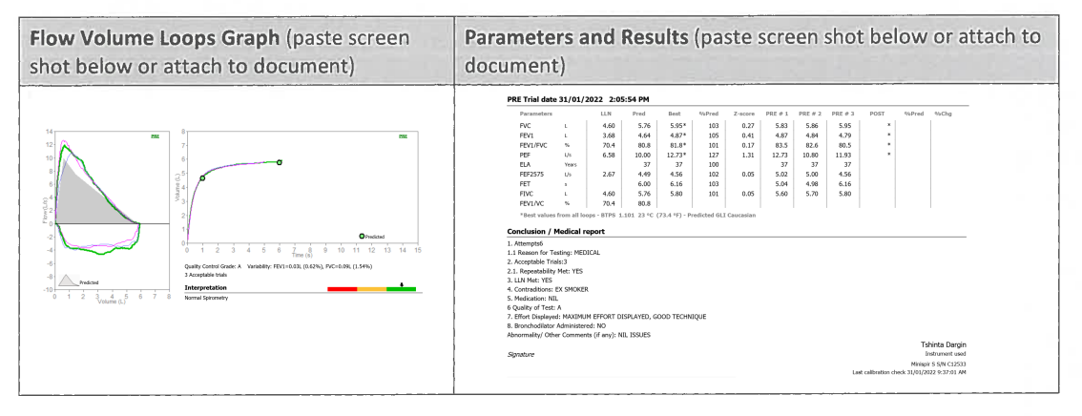

Assessment 1
Flow Volume Loops Graph (paste screen shot below or attach to document) | Parameters and Results (paste screen shot below or attach to document)

Question 1
Was a linearity calibration check completed prior to the test?
Yes ☐ | No ☐

Question 2
Where the subject demographics entered correctly?
Yes ☐ | No ☐

Question 3
Do the following trials (1-8) meet ATS/ERS acceptability criteria?
Where trials were unacceptable, document what error(s) were identified?
Trial 1 Yes ☐ Post ☐ | No ☐  Post ☐
Trial 2 Yes ☐  Post ☐ | No ☐  Post ☐
Trial 3 Yes ☐  Post ☐ | No ☐  Post ☐
Trial 4 Yes ☐  Post ☐ | No ☐  Post ☐
Trial 5 Yes ☐  Post ☐ | No ☐  Post ☐
Trial 6 Yes ☐  Post ☐ | No ☐  Post ☐
Trial 7 Yes ☐  Post ☐ | No ☐  Post ☐
Trial 8 Yes ☐  Post ☐ | No ☐  Post ☐

Question 4
Did the subject achieve 3 technically acceptable trials?
Yes ☐ | No ☐

Question 5
Does FEV1 meet ATS/ERS repeatability criteria? What was the difference between the two largest?
Yes ☐ | No ☐

Question 6
Does FVC meet ATS/ERS repeatability criteria? What was the difference between the two largest?
Yes ☐ | No ☐

Question 7
Has an appropriate technical comment been entered on the report?
Yes ☐ | No ☐

Question 8
If not normal, select which pattern is present. Please explain your reasoning. (Obstructive, Restrictive or Mixed).

You can use the flowchart below to assist, please note 5th percentile just means lower limit of normal (LLN)

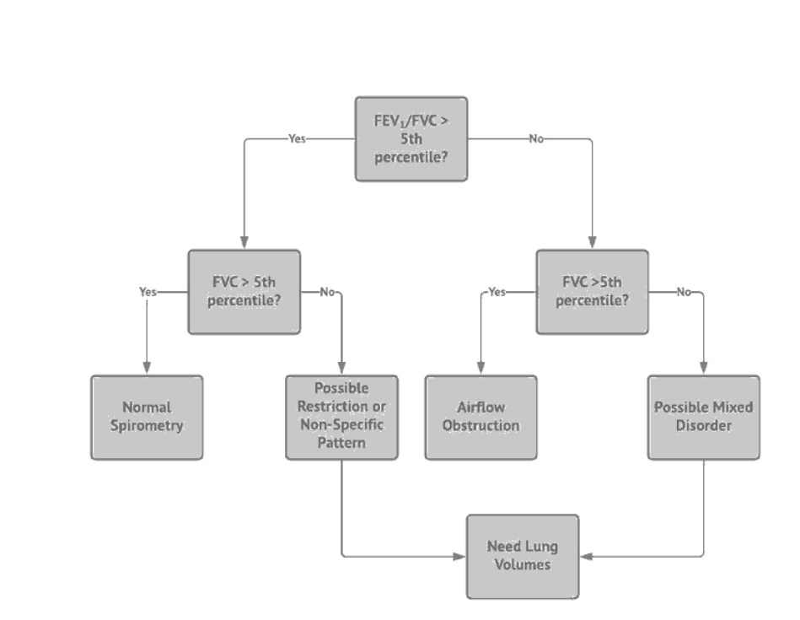

Obstruction ☐ | Restriction ☐ | Mixed  ☐
Reasoning:

Question 9
Was post-bronchodilator spirometry performed?
Yes ☐ | No ☐

Question 10  If yes, was there a significant improvement following bronchodilator? A change of >10% is considered a significant BDR response in line with the 2022 ERS / ATS interpretative standards for lung function testing |  |  | Overall Mark:  ☐Pass  ☐Fail  ☐Needs Review
Yes ☐ | No ☐ | If Yes, a significant improvement was noted in -  FEV1 by ___________%  FVC by ___________%

Assessment 2
Flow Volume Loops Graph (paste screen shot below or attach to document) | Parameters and Results (paste screen shot below or attach to document)

Question 1
Was a linearity calibration check completed prior to the test?
Yes ☐ | No ☐

Question 2
Where the subject demographics entered correctly?
Yes ☐ | No ☐

Question 3
Do the following trials (1-8) meet ATS/ERS acceptability criteria?
Where trials were unacceptable, document what error(s) were identified?
Trial 1 Yes ☐ Post ☐ | No ☐  Post ☐
Trial 2 Yes ☐  Post ☐ | No ☐  Post ☐
Trial 3 Yes ☐  Post ☐ | No ☐  Post ☐
Trial 4 Yes ☐  Post ☐ | No ☐  Post ☐
Trial 5 Yes ☐  Post ☐ | No ☐  Post ☐
Trial 6 Yes ☐  Post ☐ | No ☐  Post ☐
Trial 7 Yes ☐  Post ☐ | No ☐  Post ☐
Trial 8 Yes ☐  Post ☐ | No ☐  Post ☐

Question 4
Did the subject achieve 3 technically acceptable trials?
Yes ☐ | No ☐

Question 5
Does FEV1 meet ATS/ERS repeatability criteria? What was the difference between the two largest?
Yes ☐ | No ☐

Question 6
Does FVC meet ATS/ERS repeatability criteria? What was the difference between the two largest?
Yes ☐ | No ☐

Question 7
Has an appropriate technical comment been entered on the report?
Yes ☐ | No ☐

Question 8
If not normal, select which pattern is present. Please explain your reasoning. (Obstructive, Restrictive or Mixed).

You can use the flowchart below to assist, please note 5th percentile just means lower limit of normal (LLN)

Obstruction ☐ | Restriction ☐ | Mixed  ☐
Reasoning:

Question 9
Was post-bronchodilator spirometry performed?
Yes ☐ | No ☐

Question 10  If yes, was there a significant improvement following bronchodilator? A change of >10% is considered a significant BDR response in line with the 2022 ERS / ATS interpretative standards for lung function testing |  |  | Overall Mark:  ☐Pass  ☐Fail  ☐Needs Review
Yes ☐ | No ☐ | If Yes, a significant improvement was noted in -  FEV1 by ___________%  FVC by ___________%

Assessment 3
Flow Volume Loops Graph (paste screen shot below or attach to document) | Parameters and Results (paste screen shot below or attach to document)

Question 1
Was a linearity calibration check completed prior to the test?
Yes ☐ | No ☐

Question 2
Where the subject demographics entered correctly?
Yes ☐ | No ☐

Question 3
Do the following trials (1-8) meet ATS/ERS acceptability criteria?
Where trials were unacceptable, document what error(s) were identified?
Trial 1 Yes ☐ Post ☐ | No ☐  Post ☐
Trial 2 Yes ☐  Post ☐ | No ☐  Post ☐
Trial 3 Yes ☐  Post ☐ | No ☐  Post ☐
Trial 4 Yes ☐  Post ☐ | No ☐  Post ☐
Trial 5 Yes ☐  Post ☐ | No ☐  Post ☐
Trial 6 Yes ☐  Post ☐ | No ☐  Post ☐
Trial 7 Yes ☐  Post ☐ | No ☐  Post ☐
Trial 8 Yes ☐  Post ☐ | No ☐  Post ☐

Question 4
Did the subject achieve 3 technically acceptable trials?
Yes ☐ | No ☐

Question 5
Does FEV1 meet ATS/ERS repeatability criteria? What was the difference between the two largest?
Yes ☐ | No ☐

Question 6
Does FVC meet ATS/ERS repeatability criteria? What was the difference between the two largest?
Yes ☐ | No ☐

Question 7
Has an appropriate technical comment been entered on the report?
Yes ☐ | No ☐

Question 8
If not normal, select which pattern is present. Please explain your reasoning. (Obstructive, Restrictive or Mixed).

You can use the flowchart below to assist, please note 5th percentile just means lower limit of normal (LLN)

Obstruction ☐ | Restriction ☐ | Mixed  ☐
Reasoning:

Question 9
Was post-bronchodilator spirometry performed?
Yes ☐ | No ☐

Question 10  If yes, was there a significant improvement following bronchodilator? A change of >10% is considered a significant BDR response in line with the 2022 ERS / ATS interpretative standards for lung function testing |  |  | Overall Mark:  ☐Pass  ☐Fail  ☐Needs Review
Yes ☐ | No ☐ | If Yes, a significant improvement was noted in -  FEV1 by ___________%  FVC by ___________%

Assessment 4
Flow Volume Loops Graph (paste screen shot below or attach to document) | Parameters and Results (paste screen shot below or attach to document)

Question 1
Was a linearity calibration check completed prior to the test?
Yes ☐ | No ☐

Question 2
Where the subject demographics entered correctly?
Yes ☐ | No ☐

Question 3
Do the following trials (1-8) meet ATS/ERS acceptability criteria?
Where trials were unacceptable, document what error(s) were identified?
Trial 1 Yes ☐ Post ☐ | No ☐  Post ☐
Trial 2 Yes ☐  Post ☐ | No ☐  Post ☐
Trial 3 Yes ☐  Post ☐ | No ☐  Post ☐
Trial 4 Yes ☐  Post ☐ | No ☐  Post ☐
Trial 5 Yes ☐  Post ☐ | No ☐  Post ☐
Trial 6 Yes ☐  Post ☐ | No ☐  Post ☐
Trial 7 Yes ☐  Post ☐ | No ☐  Post ☐
Trial 8 Yes ☐  Post ☐ | No ☐  Post ☐

Question 4
Did the subject achieve 3 technically acceptable trials?
Yes ☐ | No ☐

Question 5
Does FEV1 meet ATS/ERS repeatability criteria? What was the difference between the two largest?
Yes ☐ | No ☐

Question 6
Does FVC meet ATS/ERS repeatability criteria? What was the difference between the two largest?
Yes ☐ | No ☐

Question 7
Has an appropriate technical comment been entered on the report?
Yes ☐ | No ☐

Question 8
If not normal, select which pattern is present. Please explain your reasoning. (Obstructive, Restrictive or Mixed).

You can use the flowchart below to assist, please note 5th percentile just means lower limit of normal (LLN)

Obstruction ☐ | Restriction ☐ | Mixed  ☐
Reasoning:

Question 9
Was post-bronchodilator spirometry performed?
Yes ☐ | No ☐

Question 10  If yes, was there a significant improvement following bronchodilator? A change of >10% is considered a significant BDR response in line with the 2022 ERS / ATS interpretative standards for lung function testing |  |  | Overall Mark:  ☐Pass  ☐Fail  ☐Needs Review
Yes ☐ | No ☐ | If Yes, a significant improvement was noted in -  FEV1 by ___________%  FVC by ___________%

Assessment 5
Flow Volume Loops Graph (paste screen shot below or attach to document) | Parameters and Results (paste screen shot below or attach to document)

Question 1
Was a linearity calibration check completed prior to the test?
Yes ☐ | No ☐

Question 2
Where the subject demographics entered correctly?
Yes ☐ | No ☐

Question 3
Do the following trials (1-8) meet ATS/ERS acceptability criteria?
Where trials were unacceptable, document what error(s) were identified?
Trial 1 Yes ☐ Post ☐ | No ☐  Post ☐
Trial 2 Yes ☐  Post ☐ | No ☐  Post ☐
Trial 3 Yes ☐  Post ☐ | No ☐  Post ☐
Trial 4 Yes ☐  Post ☐ | No ☐  Post ☐
Trial 5 Yes ☐  Post ☐ | No ☐  Post ☐
Trial 6 Yes ☐  Post ☐ | No ☐  Post ☐
Trial 7 Yes ☐  Post ☐ | No ☐  Post ☐
Trial 8 Yes ☐  Post ☐ | No ☐  Post ☐

Question 4
Did the subject achieve 3 technically acceptable trials?
Yes ☐ | No ☐

Question 5
Does FEV1 meet ATS/ERS repeatability criteria? What was the difference between the two largest?
Yes ☐ | No ☐

Question 6
Does FVC meet ATS/ERS repeatability criteria? What was the difference between the two largest?
Yes ☐ | No ☐

Question 7
Has an appropriate technical comment been entered on the report?
Yes ☐ | No ☐

Question 8
If not normal, select which pattern is present. Please explain your reasoning. (Obstructive, Restrictive or Mixed).

You can use the flowchart below to assist, please note 5th percentile just means lower limit of normal (LLN)

Obstruction ☐ | Restriction ☐ | Mixed  ☐
Reasoning:

Question 9
Was post-bronchodilator spirometry performed?
Yes ☐ | No ☐

Question 10  If yes, was there a significant improvement following bronchodilator? A change of >10% is considered a significant BDR response in line with the 2022 ERS / ATS interpretative standards for lung function testing |  |  | Overall Mark:  ☐Pass  ☐Fail  ☐Needs Review
Yes ☐ | No ☐ | If Yes, a significant improvement was noted in -  FEV1 by ___________%  FVC by ___________%

Assessment 6
Flow Volume Loops Graph (paste screen shot below or attach to document) | Parameters and Results (paste screen shot below or attach to document)

Question 1
Was a linearity calibration check completed prior to the test?
Yes ☐ | No ☐

Question 2
Where the subject demographics entered correctly?
Yes ☐ | No ☐

Question 3
Do the following trials (1-8) meet ATS/ERS acceptability criteria?
Where trials were unacceptable, document what error(s) were identified?
Trial 1 Yes ☐ Post ☐ | No ☐  Post ☐
Trial 2 Yes ☐  Post ☐ | No ☐  Post ☐
Trial 3 Yes ☐  Post ☐ | No ☐  Post ☐
Trial 4 Yes ☐  Post ☐ | No ☐  Post ☐
Trial 5 Yes ☐  Post ☐ | No ☐  Post ☐
Trial 6 Yes ☐  Post ☐ | No ☐  Post ☐
Trial 7 Yes ☐  Post ☐ | No ☐  Post ☐
Trial 8 Yes ☐  Post ☐ | No ☐  Post ☐

Question 4
Did the subject achieve 3 technically acceptable trials?
Yes ☐ | No ☐

Question 5
Does FEV1 meet ATS/ERS repeatability criteria? What was the difference between the two largest?
Yes ☐ | No ☐

Question 6
Does FVC meet ATS/ERS repeatability criteria? What was the difference between the two largest?
Yes ☐ | No ☐

Question 7
Has an appropriate technical comment been entered on the report?
Yes ☐ | No ☐

Question 8
If not normal, select which pattern is present. Please explain your reasoning. (Obstructive, Restrictive or Mixed).

You can use the flowchart below to assist, please note 5th percentile just means lower limit of normal (LLN)

Obstruction ☐ | Restriction ☐ | Mixed  ☐
Reasoning:

Question 9
Was post-bronchodilator spirometry performed?
Yes ☐ | No ☐

Question 10  If yes, was there a significant improvement following bronchodilator? A change of >10% is considered a significant BDR response in line with the 2022 ERS / ATS interpretative standards for lung function testing |  |  | Overall Mark:  ☐Pass  ☐Fail  ☐Needs Review
Yes ☐ | No ☐ | If Yes, a significant improvement was noted in -  FEV1 by ___________%  FVC by ___________%

Assessment 7
Flow Volume Loops Graph (paste screen shot below or attach to document) | Parameters and Results (paste screen shot below or attach to document)

Question 1
Was a linearity calibration check completed prior to the test?
Yes ☐ | No ☐

Question 2
Where the subject demographics entered correctly?
Yes ☐ | No ☐

Question 3
Do the following trials (1-8) meet ATS/ERS acceptability criteria?
Where trials were unacceptable, document what error(s) were identified?
Trial 1 Yes ☐ Post ☐ | No ☐  Post ☐
Trial 2 Yes ☐  Post ☐ | No ☐  Post ☐
Trial 3 Yes ☐  Post ☐ | No ☐  Post ☐
Trial 4 Yes ☐  Post ☐ | No ☐  Post ☐
Trial 5 Yes ☐  Post ☐ | No ☐  Post ☐
Trial 6 Yes ☐  Post ☐ | No ☐  Post ☐
Trial 7 Yes ☐  Post ☐ | No ☐  Post ☐
Trial 8 Yes ☐  Post ☐ | No ☐  Post ☐

Question 4
Did the subject achieve 3 technically acceptable trials?
Yes ☐ | No ☐

Question 5
Does FEV1 meet ATS/ERS repeatability criteria? What was the difference between the two largest?
Yes ☐ | No ☐

Question 6
Does FVC meet ATS/ERS repeatability criteria? What was the difference between the two largest?
Yes ☐ | No ☐

Question 7
Has an appropriate technical comment been entered on the report?
Yes ☐ | No ☐

Question 8
If not normal, select which pattern is present. Please explain your reasoning. (Obstructive, Restrictive or Mixed).

You can use the flowchart below to assist please note 5th percentile just means lower limit of normal (LLN)

Obstruction ☐ | Restriction ☐ | Mixed  ☐
Reasoning:

Question 9
Was post-bronchodilator spirometry performed?
Yes ☐ | No ☐

Question 10  If yes, was there a significant improvement following bronchodilator? A change of >10% is considered a significant BDR response in line with the 2022 ERS / ATS interpretative standards for lung function testing |  |  | Overall Mark:  ☐Pass  ☐Fail  ☐Needs Review
Yes ☐ | No ☐ | If Yes, a significant improvement was noted in -  FEV1 by ___________%  FVC by ___________%

Assessment 8
Flow Volume Loops Graph (paste screen shot below or attach to document) | Parameters and Results (paste screen shot below or attach to document)

Question 1
Was a linearity calibration check completed prior to the test?
Yes ☐ | No ☐

Question 2
Where the subject demographics entered correctly?
Yes ☐ | No ☐

Question 3
Do the following trials (1-8) meet ATS/ERS acceptability criteria?
Where trials were unacceptable, document what error(s) were identified?
Trial 1 Yes ☐ Post ☐ | No ☐  Post ☐
Trial 2 Yes ☐  Post ☐ | No ☐  Post ☐
Trial 3 Yes ☐  Post ☐ | No ☐  Post ☐
Trial 4 Yes ☐  Post ☐ | No ☐  Post ☐
Trial 5 Yes ☐  Post ☐ | No ☐  Post ☐
Trial 6 Yes ☐  Post ☐ | No ☐  Post ☐
Trial 7 Yes ☐  Post ☐ | No ☐  Post ☐
Trial 8 Yes ☐  Post ☐ | No ☐  Post ☐

Question 4
Did the subject achieve 3 technically acceptable trials?
Yes ☐ | No ☐

Question 5
Does FEV1 meet ATS/ERS repeatability criteria? What was the difference between the two largest?
Yes ☐ | No ☐

Question 6
Does FVC meet ATS/ERS repeatability criteria? What was the difference between the two largest?
Yes ☐ | No ☐

Question 7
Has an appropriate technical comment been entered on the report?
Yes ☐ | No ☐

Question 8
If not normal, select which pattern is present. Please explain your reasoning. (Obstructive, Restrictive or Mixed).

You can use the flowchart below to assist, please note 5th percentile just means lower limit of normal (LLN)

Obstruction ☐ | Restriction ☐ | Mixed  ☐
Reasoning:

Question 9
Was post-bronchodilator spirometry performed?
Yes ☐ | No ☐

Question 10  If yes, was there a significant improvement following bronchodilator? A change of >10% is considered a significant BDR response in line with the 2022 ERS / ATS interpretative standards for lung function testing |  |  | Overall Mark:  ☐Pass  ☐Fail  ☐Needs Review
Yes ☐ | No ☐ | If Yes, a significant improvement was noted in -  FEV1 by ___________%  FVC by ___________%

Assessment 9
Flow Volume Loops Graph (paste screen shot below or attach to document) | Parameters and Results (paste screen shot below or attach to document)

Question 1
Was a linearity calibration check completed prior to the test?
Yes ☐ | No ☐

Question 2
Where the subject demographics entered correctly?
Yes ☐ | No ☐

Question 3
Do the following trials (1-8) meet ATS/ERS acceptability criteria?
Where trials were unacceptable, document what error(s) were identified?
Trial 1 Yes ☐ Post ☐ | No ☐  Post ☐
Trial 2 Yes ☐  Post ☐ | No ☐  Post ☐
Trial 3 Yes ☐  Post ☐ | No ☐  Post ☐
Trial 4 Yes ☐  Post ☐ | No ☐  Post ☐
Trial 5 Yes ☐  Post ☐ | No ☐  Post ☐
Trial 6 Yes ☐  Post ☐ | No ☐  Post ☐
Trial 7 Yes ☐  Post ☐ | No ☐  Post ☐
Trial 8 Yes ☐  Post ☐ | No ☐  Post ☐

Question 4
Did the subject achieve 3 technically acceptable trials?
Yes ☐ | No ☐

Question 5
Does FEV1 meet ATS/ERS repeatability criteria? What was the difference between the two largest?
Yes ☐ | No ☐

Question 6
Does FVC meet ATS/ERS repeatability criteria? What was the difference between the two largest?
Yes ☐ | No ☐

Question 7
Has an appropriate technical comment been entered on the report?
Yes ☐ | No ☐

Question 8
If not normal, select which pattern is present. Please explain your reasoning. (Obstructive, Restrictive or Mixed).

You can use the flowchart below to assist, please note 5th percentile just means lower limit of normal (LLN)

Obstruction ☐ | Restriction ☐ | Mixed  ☐
Reasoning:

Question 9
Was post-bronchodilator spirometry performed?
Yes ☐ | No ☐

Question 10  If yes, was there a significant improvement following bronchodilator? A change of >10% is considered a significant BDR response in line with the 2022 ERS / ATS interpretative standards for lung function testing |  |  | Overall Mark:  ☐Pass  ☐Fail  ☐Needs Review
Yes ☐ | No ☐ | If Yes, a significant improvement was noted in -  FEV1 by ___________%  FVC by ___________%

Assessment 10
Flow Volume Loops Graph (paste screen shot below or attach to document) | Parameters and Results (paste screen shot below or attach to document)

Question 1
Was a linearity calibration check completed prior to the test?
Yes ☐ | No ☐

Question 2
Where the subject demographics entered correctly?
Yes ☐ | No ☐

Question 3
Do the following trials (1-8) meet ATS/ERS acceptability criteria?
Where trials were unacceptable, document what error(s) were identified?
Trial 1 Yes ☐ Post ☐ | No ☐  Post ☐
Trial 2 Yes ☐  Post ☐ | No ☐  Post ☐
Trial 3 Yes ☐  Post ☐ | No ☐  Post ☐
Trial 4 Yes ☐  Post ☐ | No ☐  Post ☐
Trial 5 Yes ☐  Post ☐ | No ☐  Post ☐
Trial 6 Yes ☐  Post ☐ | No ☐  Post ☐
Trial 7 Yes ☐  Post ☐ | No ☐  Post ☐
Trial 8 Yes ☐  Post ☐ | No ☐  Post ☐

Question 4
Did the subject achieve 3 technically acceptable trials?
Yes ☐ | No ☐

Question 5
Does FEV1 meet ATS/ERS repeatability criteria? What was the difference between the two largest?
Yes ☐ | No ☐

Question 6
Does FVC meet ATS/ERS repeatability criteria? What was the difference between the two largest?
Yes ☐ | No ☐

Question 7
Has an appropriate technical comment been entered on the report?
Yes ☐ | No ☐

Question 8
If not normal, select which pattern is present. Please explain your reasoning. (Obstructive, Restrictive or Mixed).

You can use the flowchart below to assist please note 5th percentile just means lower limit of normal (LLN)

Obstruction ☐ | Restriction ☐ | Mixed  ☐
Reasoning:

Question 9
Was post-bronchodilator spirometry performed?
Yes ☐ | No ☐

Question 10  If yes, was there a significant improvement following bronchodilator? A change of >10% is considered a significant BDR response in line with the 2022 ERS / ATS interpretative standards for lung function testing |  |  | Overall Mark:  ☐Pass  ☐Fail  ☐Needs Review
Yes ☐ | No ☐ | If Yes, a significant improvement was noted in -  FEV1 by ___________%  FVC by ___________%

